

Product Catalog System

How to create a company
Go to the Companies tab
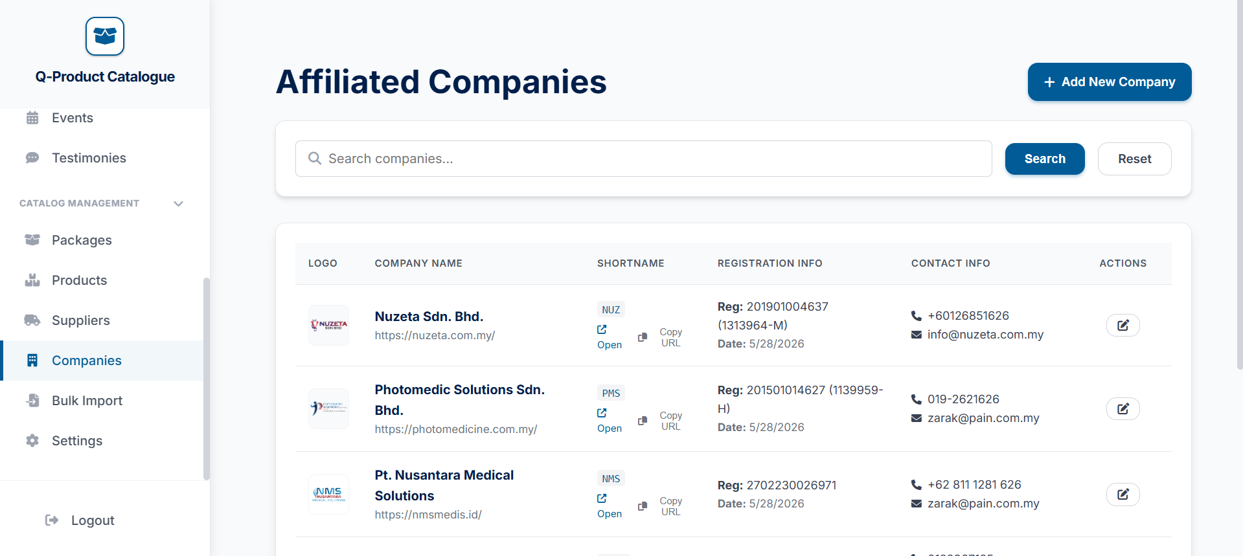


Click on the add new company button at the top

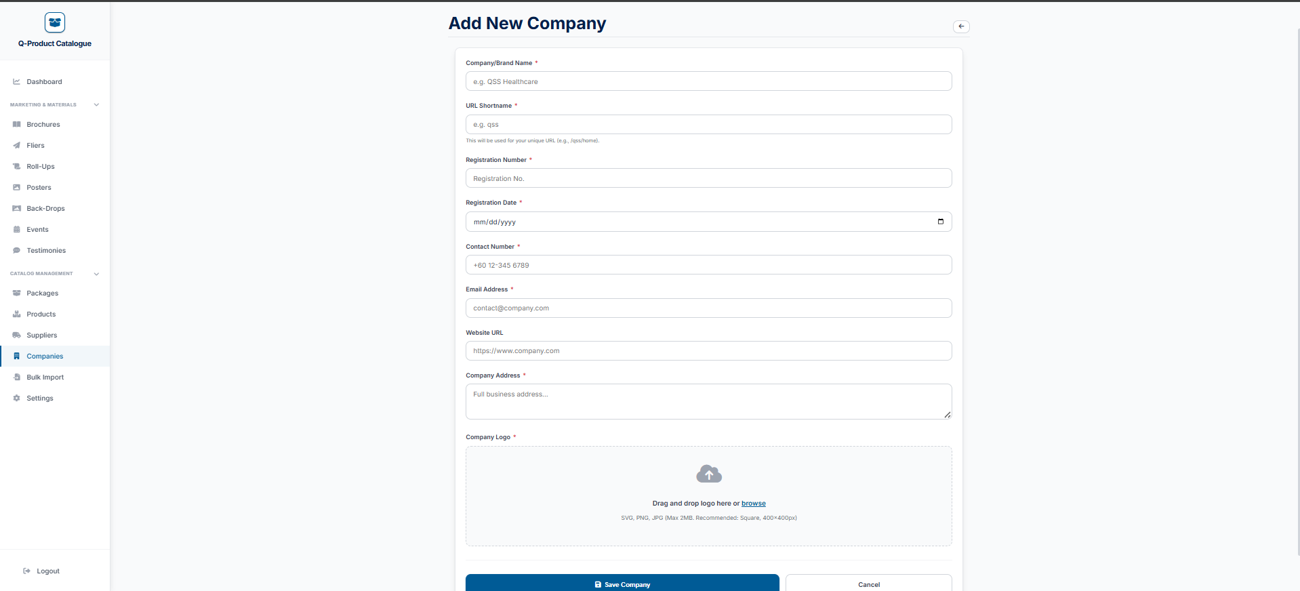
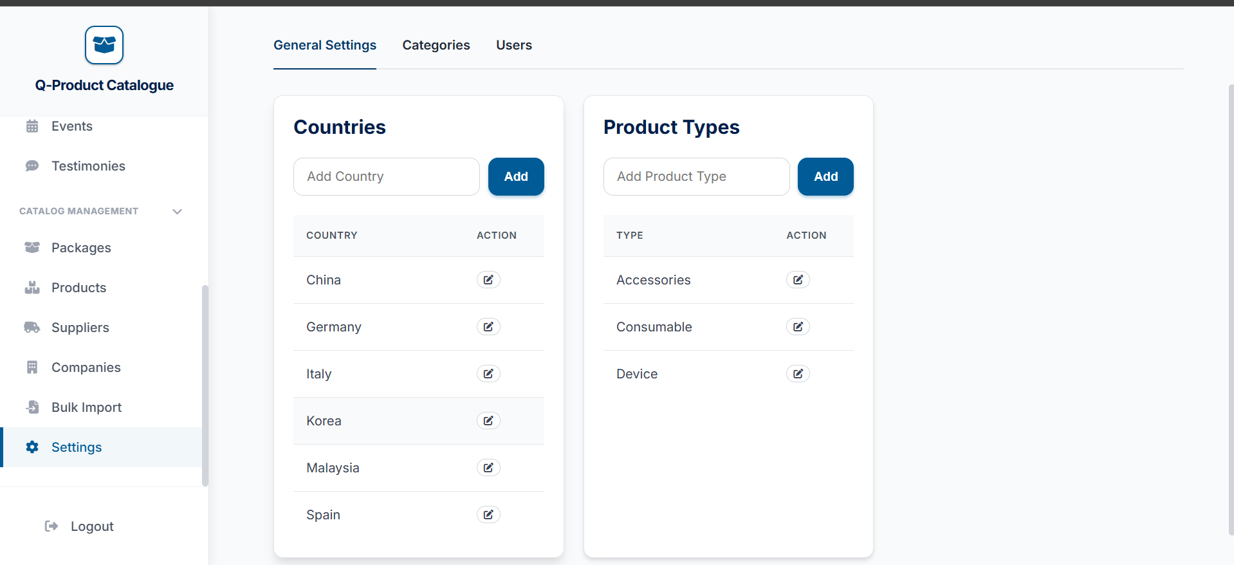

After filling, just press the save company button
Fill out this form and the details that are starred are required to fill
Enter the country you want here
Enter the country you want here


Enter the country you want here

